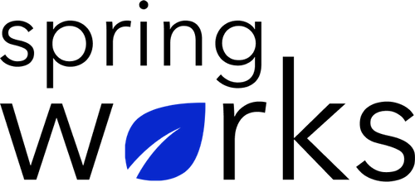
Free Template – Safety Culture Survey

Use this survey in determining whether or not the safety measures in place are adequate, or more safety measures should be introduced. Copy this template to your Google Drive and customize it for your organization.

Communication (to be added as review instructions):

Your responses to this survey are anonymous. The leaders are committed to analyzing your results and taking action. Please answer this quick survey by <HOUR OF THE DAY> on <DATE>.

Thank you for your time. Your responses will help our organization become a better place to work. If you have any questions about the survey, please contact [insert name of contact person].

Demographic Information:

The following information is requested so that meaningful analysis and comparisons of group results can be made. Please check the circle corresponding to your answer.

Q: Your Gender:

- Male
- Female

Q: Your Department:

- Marketing
- Operations
- Tech
- Accounting
- HR

Q: Company Service:

- Under 1 Year
- 1-2 Year
- 3-5 Year
- 6-10 Year
- 10-15 Year
Employee Motivation Questionnaire

To answer clearly what you think or feel about each item, please follow these steps:

- Read each item fully before you start to mark your answer.
- Pick the one answer which most nearly says what you think or how you feel.
- While completing the questions, be sure to read the special instructions which are included.

Choose the most appropriate answer:

Q: I feel safe at my workplace:

- Strongly agree
- Agree
- Neutral
- Disagree
- Strongly disagree

Q: I feel safe on my way to work:

- Strongly agree
- Agree
- Neutral
- Disagree
- Strongly disagree

Q: How dedicated do you perceive your organization to be toward employee safety?

😞 😏 😐 😊 😀

Q: How well do you understand your rights and responsibilities concerning safety at your workplace?

😞 😏 😐 😊 😀

Q: There is a regular exchange about safety-related issues between employees and management:

- Strongly agree
- Agree
- Neutral
- Disagree
- Strongly disagree

Q: Any security concerns raised are treated with high urgency in my organization:

- Strongly agree
- Agree
- Neutral
- Disagree
- Strongly disagree

Q: All incidents are investigated quickly in order to improve safety at the workplace as soon as possible:

- Strongly agree
- Agree
- Neutral
- Disagree
- Strongly disagree

Q: I am aware of the building's emergency evacuation plan:

- Strongly agree
- Agree
- Neutral
- Disagree
- Strongly disagree

Q: I know the location of my building's emergency utensils (such as fire extinguishers or first aid kits):

- Strongly agree
- Agree
- Neutral
- Disagree
- Strongly disagree

Q: I feel informed about possible safety hazards at my workplace:

- Strongly agree
- Agree
- Neutral
- Disagree
- Strongly disagree

Q: What could the organization do to increase safety at your workplace?

Q: Do you have any additional comments, questions, or concerns regarding the safety culture in the organization?

